Checklist for Installation and Setup of GETLinked ARLink

___Installation

____1. If you are installing into a Great Plains product, we strongly recommend that you first backup your Accounting system.
____2. Load the GETLinked CD ROM. InstallShield will take you through the installation automatically. Double-click “Setup” if the program does not install automatically. You are then ready to run the program from the “Start” menu.
____3. If you download our product from the Internet simply double-click the GETLinked.exe file and the Install Shield will take you through the installation automatically.
Note: If you are a Great Plains Dynamics or eEnterprise customer, once you launch the Great Plains product a question will ask to include the new code. Answer “YES”.

___ARLink Location Setup

The ARLink Module gathers customer information and sales data from a remote system through the import function. Once the data is in the ARLink Module it can be reviewed and reconciled. When importing the data exception reports will list errors such as missing customers. The receivables information can then be transferred to the Accounts Receivable module of the selected accounting system.

____1. On the menu bar go to Setup>>ARLink. (For Great Plains users, all GETLinked access is from the “Extras” field on the menu bar within the Great Plains product.)
____2 In the Location field enter the user-defined location ID. For businesses with several locations or stores, this is used to identify each location. If only one location exists, then one location ID is required. Once setup, this field cannot be changed. This is a 15 character alphanumeric field where an abbreviated location name or location number is entered. In the 30-character Name field the complete description of the location is entered.
____3 The Default checkbox can be marked to flag this setup information as the template to setup all other locations. After completing all the setup information for the first location, upon entering the Location and Name of the next location the Copy Default button can be used to copy the default setup information into the new location.
____4. An Alias and the Franchise ID fields can also be used to further describe this location but they are not required. These fields are only used by selected import systems.

___ARLink Setup Import Tab

The Import tab allows you to setup information specific to the data you wish to import from the remote system.

____1. The Allow Multiple Imports field can be set to Yes No or Ask from the drop-down list. If you want the system to ask you if you want to import data that you have already imported then choose Ask, which is what is typically recommended. The Yes setting will just import again without asking and the No setting will not allow importing of data that has been previously imported.
____2. To setup this information, select the system, model (if applicable), and version (if applicable) from the drop-down arrows then press the Setup button. Please refer to the appendix section of this manual for the setup information related to the specific system from which the data is being imported.
____3. In the Setup window specific to the system you selected there may be additional setup buttons. When these buttons are selected the system may ask for a specific file. If it is asking for a file it will open a browse window stating the specific file name it is looking for at the top of the window. Once the correct file is selected, choose Open. The system may ask additional files so make certain you are reading the file names at the top of the window carefully.
____4. If you need the system to translate customer numbers and account numbers from one system to the other than you will need to mark the Translate Customers and Translate Accounts checkboxes. For example, if the data from a Point of Sale system is imported into the GETLinked system with a customer number that does not match the customer number in the accounting system than we need to put a translation in the system for that customer. Please refer to the translation setup instructions later in this document. Typically these are both marked.
____5. The pathnames in the scrolling window on the Import tab need to be selected on the Pathname line so the system knows where to find the remote data files. Using the Yellow Folder icon on the Pathname line you can browse to the directory where the data is stored. By marking the Variable option for either the Pathname or the Filename you can choose to date stamp the directories and/or files. Using the dropdown arrows in the Variable Options fields you can choose from a variety of options.
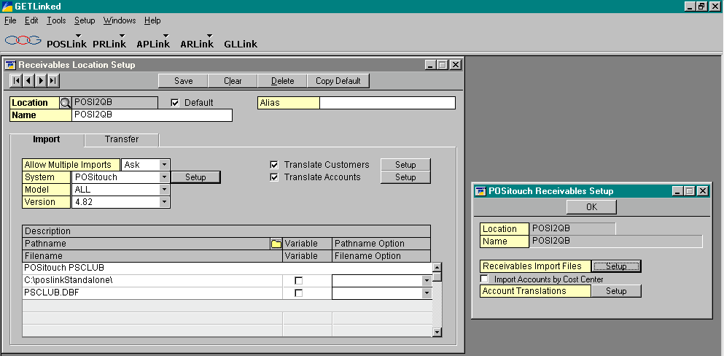

___ARLink Setup Transfer Tab

The Transfer tab allows you to setup information specific to the accounting system you wish to transfer data to.

____1. The Allow Multiple Transfers field can be set to Yes No or Ask from the drop-down list. If you want the system to ask you if you want to transfer data that you have already transferred then choose Ask, which is what is typically recommended. The Yes setting will just transfer again without asking and the No setting will not allow importing of data that has been previously imported. Transferring the same data multiple times is risky as you may be doubling the information in your accounting system. It is always strongly recommended that you have a backup of your accounting system before transferring from the GETLinked program.
____2. To setup the transfer information, select the system, model (if applicable), and version (if applicable) from the drop-down arrows then press the Setup button next to the Transfer System. Please refer to the appendix section of this manual for the setup information related to the specific accounting system where the data is being transferred.
____3. If you are transferring information to the QuickBooks accounting system the Receivables Account must be entered
____4. The Apply To is only required with certain Accounting Systems. Leave this field blank unless it is needed.
____5. The Customer Numbering information is only required with certain accounting systems. Leave this information blank unless it is needed.
____6. The Pathname in the scrolling window on the Transfer tab and the Filename needs to be selected so the system knows where to send the transfer file that the accounting system will import. Using the Yellow Folder icon on the Pathname line you can browse to the directory where you want the file to be sent. By marking the Variable option for either the Pathname or the Filename you can choose to date stamp the directories and/or files. Using the dropdown arrows in the Variable Options fields you can choose from a variety of options.

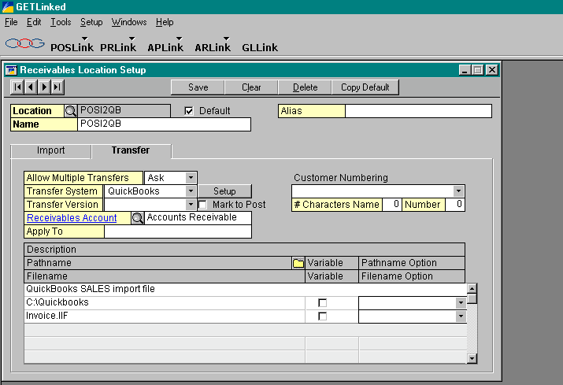

___Customer Setup

The customer information must be imported in from the remote system and translated to the correct customer information for the accounting system. Typically this is done by importing the transactions from the remote data and then building the customer information from the transactions. This may be an ongoing process if new customers are continuously added.

____1. From the Tool Bar go to ARLink>>Import and Transfer. From the Locations Available select your location and choose Insert to add it to Locations Selected. Choose the Transactions tab and the Import/Transfer Option should be Import Only. Select an Import Date Range. Select the Starting Date and Ending Date for the remote data you wish to import. You can either type in the date or you can click on the calendar button. From the Calendar button select the month using the inside arrows on each side of the month, select the year using the outside arrows, highlight the date and then Select. These dates would be the date range of the receivables information you wish to transfer to your accounting system. The Flash Windows selection will show the data being imported. Once the system is finished importing the Transactions the system will ask for a Report Destination where you can choose to send the report to the screen or the printer or both. The reports can be many pages so it is recommended that you unmark Printer and select Screen. If you then decide you want to print the report after you review it on the screen you can print it. The first report will be the RM Transaction Import report listing all the transactions that were brought in from the remote system. The second report will be an Error Report listing any errors such as customer not found or account not found. Initially we would expect to see customers not found since the customers have not been built.

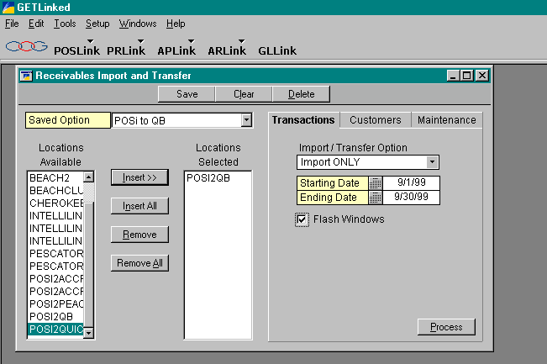

____2. To build the customers choose the Maintenance Tab on the Receivables Import and Transfer window. Your date range should still be selected. Under Build Translations select Build next to Customers. The screen will adjust to the Transactions tab when it is finished. After building you are ready to translate the information.

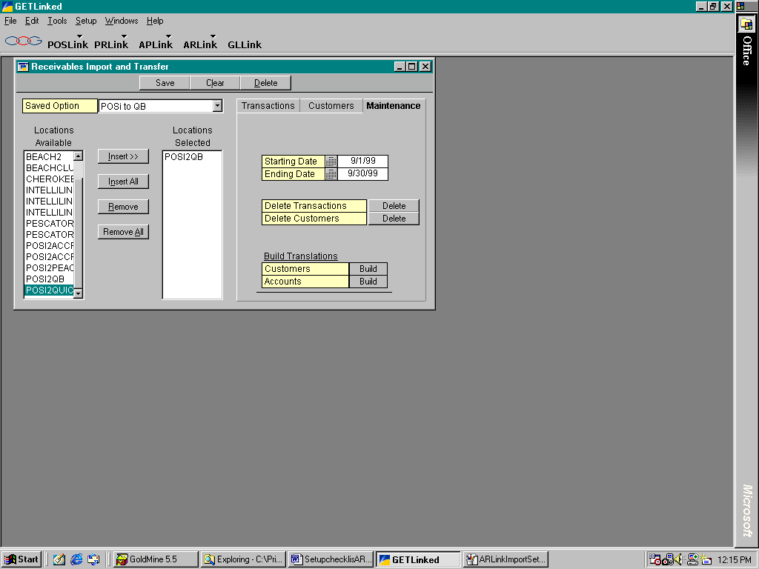

___ARLink Setup Customer Translations

This window is designed to translate the customer information that comes over from the remote system into the customer numbers/names required by the accounting system we are transferring the information to.

____1. On the menu bar go to Setup>>ARLink>>Customer Translations. Select your location using the Looking Glass. In the left hand column under Imported Customer you should see the customer information from the remote system. In the right hand column under Assigned Customer you must select the customer number from the accounting system that ties to the information from the remote system. If the system asked for a customer file from the accounting system when you were setting up the Transfer Information (refer to the ARLink Transfer Tab section) you may be able to see your Customers by using the Looking Glass next to Assigned Customer at the top of the column. If your customers are available you can go down the column and next to each Imported Customer you can select a customer from your list under Assigned Customer. If you do not have access to your customers from the Customer Lookup window then you need to type in the customer numbers/names exactly as they appear in your accounting system. We recommend you have a customer list in front of you when typing the information.

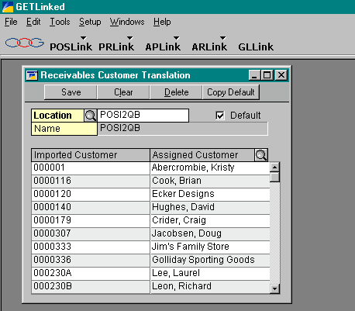

___Account Setup

The account information must be imported in from the remote system and translated to the correct account information for the accounting system. Typically this is done by importing the transactions from the remote data and then building the account information from the transactions.

____1. To build the accounts choose the Maintenance Tab on the Receivables Import and Transfer window. Your date range should be the same range you used when importing the transactions in for the customer build. Under Build Translations select Build next to Accounts. The screen will adjust to the Transactions tab when it is finished. After building you are ready to translate the information.

___ARLink Setup Account Translations

This window is designed to translate the account information that comes over from the remote system into the account numbers required by the accounting system we are transferring the information to.

____1. On the menu bar go to Setup>>ARLink>>Account Translations. Select your location using the Looking Glass. In the left hand column under Account Imported you should see the account/cost center information from the remote system. In the right hand column under Account Assigned you must select the account number from the accounting system that ties to the information from the remote system. If the system asked for an account file from the accounting system when you were setting up the Transfer Information (refer to the ARLink Transfer Tab section) you may be able to see your Chart of Accounts by using the Looking Glass next to Account Assigned at the top of the column. If your accounts are available you can go down the column and next to each Account Imported you can select an account from your chart of accounts under Account Assigned. If you do not have access to your chart of accounts from the Account Lookup window then you must type in the correct account number exactly as it reads in your accounting system. It is recommended that you have a Chart of Accounts list in front of you when setting up this information.

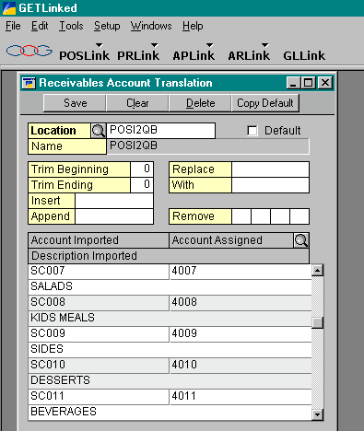

Once setup is completed you must go back to ARLink>>Import and Transfer. Insert your location and go to the Maintenance Tab. Choose Delete next to Delete Transactions. You are now ready to import and transfer your remote data to the Financial System. Refer to the Daily Receivables Procedures section of the checklist.

